300 Blackout Ballistics
- Ammo Topics, Ballistic Charts & Data
- January 23, 2021
- David Lewis
- comments
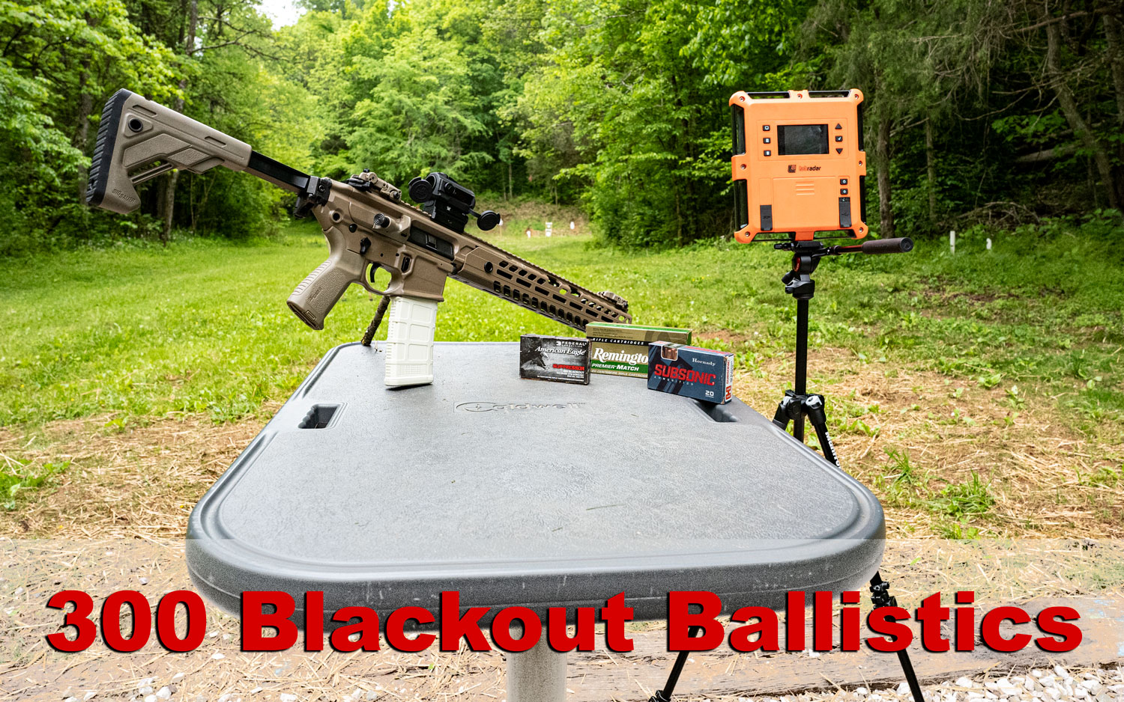


David Lewis

EDITOR
PROFILE

A look at 300 Blackout ballistics including velocity, energy and drop data for some of the most popular loads among American shooters.
300 Blackout is taking the shooting world by storm, and for good reason. Let’s explore all this caliber has to offer including an in-depth look at 300 Blackout Ballistics.

Fast Facts About 300 Blackout
- The 300 AAC Blackout delivers ballistic performance comparable to 7.62×39, yet possesses a base diameter that optimizes functionality in an AR-type platform. It is cross-compatible with 223 Rem/5.56×45 magazines.
- The 300 Blackout’s .30 caliber bullet can be made especially long, and as the result may weigh up to 220 grains — quadruple the weight of the typical 223 Rem round’s. So heavy a bullet conveys a subsonic muzzle velocity and correspondingly softer report.
- Converting an AR-15 to fire 300 Blackout is as simple as swapping its barrel.
- Although functionally identical to the 300 Whisper, the 300 AAC Blackout is its own SAAMI standardized cartridge.

300 Blackout Ballistic Table
 |  | Velocity (Feet per Second) | Energy (Ft. Pounds) |  |  |  |  |  |  |  |  | Bullet Drop (Inches) |  |  |  |  |  |  |  |  | Ballistic Coefficient
Ammo Name |  | Barrel Length | Muzzle | 100 Yards | 200 Yards |  |  | 300 Yards |  | 400 Yards |  | 500 Yards | Muzzle | 100 Yards |  |  | 200 Yards |  | 300 Yards |  | 400 Yards | 500 Yards | Muzzle |  | 100 Yards | 200 Yards | 300 Yards | 400 Yards | 500 Yards | G1 | G7 | Sect. Density
Magtech 200 Grain FMJ |  | 16 | 1017 | 980 | 948 |  |  | 920 |  |  |  |  | 459 | 427 |  |  | 399 |  | 376 |  |  |  | - |  | 0 | -36.2 | -110.9 |  |  | 0.57 | 0.253 | 0.301
Sellier & Bellot 200 Grain FMJ Subsonic |  | 16 | 1060 | 979 | 917 |  |  | 869 |  | 835 |  |  | 500 | 427 |  |  | 374 |  | 337 |  | 311 |  | - |  | 0 | -34.3 | -109.9 | -231.4 |  | 0.301 | 0.142 | 0.301
Hornady 110 Grain V-MAX |  | 16 | 2375 | 2094 | 1833 |  |  | 1596 |  |  |  |  | 1378 | 1071 |  |  | 820 |  | 622 |  |  |  | -1.5 |  | 3.2 | 0 | -13.7 |  |  | 0.295 | 0.15 | 0.166
Fiocchi 150 Grain FMJ-BT |  | 16 | 1950 | 1767 | 1597 |  |  | 1442 |  | 1305 |  | 1190 | 1266 | 1039 |  |  | 849 |  | 693 |  | 567 | 472 | -0.52 |  | 0 | -9.7 | -33.1 |  |  | 0.398 |  | 0.226
Hornady 125 Grain HP American Gunner |  | 16 | 2175 | 1932 | 1707 |  |  | 1504 |  |  |  |  | 1313 | 1036 |  |  | 809 |  | 627 |  |  |  | -1.5 |  | 3.9 | 0 | -15.9 |  |  | 0.325 | 0.168 | 0.128
Fiocchi Extrema 125 Grain SST |  | 16 | 2200 | 1944 | 1708 |  |  | 1496 |  | 1312 |  | 1166 | 1343 | 1049 |  |  | 810 |  | 621 |  | 478 | 377 | -0.54 |  | 0 | -7.7 | -27.5 |  |  | 0.305 |  | 0.188
Magtech First Defense 123 Grain FMJ |  | 16 | 2230 | 1990 | 1766 |  |  | 1561 |  |  |  |  | 1359 | 1082 |  |  | 852 |  | 666 |  |  |  | - |  | 0 | -8.8 | -28.8 |  |  | 0.334 | 0.171 | 0.185
Federal 220 Grain OTM Subsonic |  | 16 | 1000 | 970 | 944 |  |  | 920 |  | 897 |  | 876 | 488 | 460 |  |  | 435 |  | 413 |  | 393 | 375 | - |  | 17.8 | 0 | -56.9 | -154.7 | -294.9 | 0.659 | 0.304 | 0.331
Sellier & Bellot 147 Grain FMJ |  | 16 | 2077 | 1882 | 1706 |  |  | 1547 |  | 1402 |  |  | 1411 | 1159 |  |  | 953 |  | 783 |  | 643 |  | - |  | 0 | -7.9 | -27.7 | -62.2 |  | 0.407 | 0.204 | 0.221
Hornady Black 208 Grain A-MAX |  | 16 | 1020 | 987 | 959 |  |  |  |  |  |  |  | 480 | 454 |  |  | 424 |  |  |  |  |  | -1.5 |  | 0 | -33.5 |  |  |  | 0.787 | 0.341 | 0.313
Prvi 125 Grain FMJ |  | 16 | 2198 | 1935 | 1696 |  |  | 1486 |  |  |  |  | 1340 | 1038 |  |  | 797 |  | 611 |  |  |  | - |  | 0 | -2.7 | -24.8 |  |  | 0.325
Magtech First Defense 115 Grain OTM |  | 16 | 2280 | 2033 | 1803 |  |  | 1591 |  |  |  |  | 1328 | 1056 |  |  | 830 |  | 647 |  |  |  | - |  | 0 | -8.5 | -27.7 |  |  | 0.328 | 0.168 | 0.173
Hornady 190 Grain SUB-X |  | 16 | 1050 | 998 | 956 |  |  | 919 |  | 886 |  | 856 | 465 | 420 |  |  | 385 |  | 356 |  | 331 | 309 | -1.5 |  | 0 | -33.4 | -104.6 | -217.3 | -374.2 | 0.444 | 0.206 | 0.286
Sellier & Bellot 124 Grain FMJ |  | 16 | 2165 | 1901 | 1669 |  |  | 1465 |  | 1286 |  |  | 1285 | 990 |  |  | 763 |  | 588 |  | 453 |  | - |  | 0 | -7.7 | -28 | -64.5 |  | 0.309 | 0.165 | 0.187
Barnes 110 Grain TAC-TX |  | 16 | 2350 | 2070 | 1810 |  |  | 1574 |  | 1369 |  |  | 1349 | 1046 |  |  | 800 |  | 606 |  | 458 |  | -2.5 |  | 0 | -5.7 | -22 | -52.5 |  | 0.294 | 0.153 | 0.166
Hornady 135 Grain FTX |  | 16 | 2085 | 1813 | 1563 |  |  | 1349 |  |  |  |  | 1303 | 985 |  |  | 732 |  | 545 |  |  |  | -1.5 |  | 5 | 0 | -18.9 |  |  | 0.274 | 0.147 | 0.203
Black Hills 110 Grain TTSX |  | 16 | 2250 |  |  |  |  |  |  |  |  |  | 1237 |  |  |  |  |  |  |  |  |  |  |  |  |  |  |  |  | 0.166
Scroll right to see energy, drop and coefficient data.

300 AAC Blackout Development
Advanced Armament Corporation began developing a .30 caliber subsonic cartridge optimized for the M4 platform in 2009. They first looked to the 7.62×39 for inspiration. After investigation, AAC found the 7.62×39 case’s aggressive taper too extreme for a standard M4 magazine to accommodate. They instead heavily based their new cartridge on SSK Industries’ 300 Whisper. Eventually, they got their own 300 Blackout cartridge SAAMI approved in 2011.

Who Uses It?
The 300 Blackout would never see mainstream military use, although it became popular in the civilian shooter market. It is extremely easy to convert an AR-15 to fire 300 Blackout ammunition, and the round’s ballistic performance is different enough to justify purchasing the barrel necessary to do so. A supersonic 300 Blackout round with a 110 grain bullet has a muzzle velocity approximately 1,000 fps slower than that of a 223 Rem, giving it a significantly faster bullet drop. However, the 300 Blackout’s heavier bullet compensates for its lesser speed to grant it an effective muzzle energy, and its 0.84” greater diameter enables it to inflict a wider wound channel.

Common Bullet Weights for 300 BLK
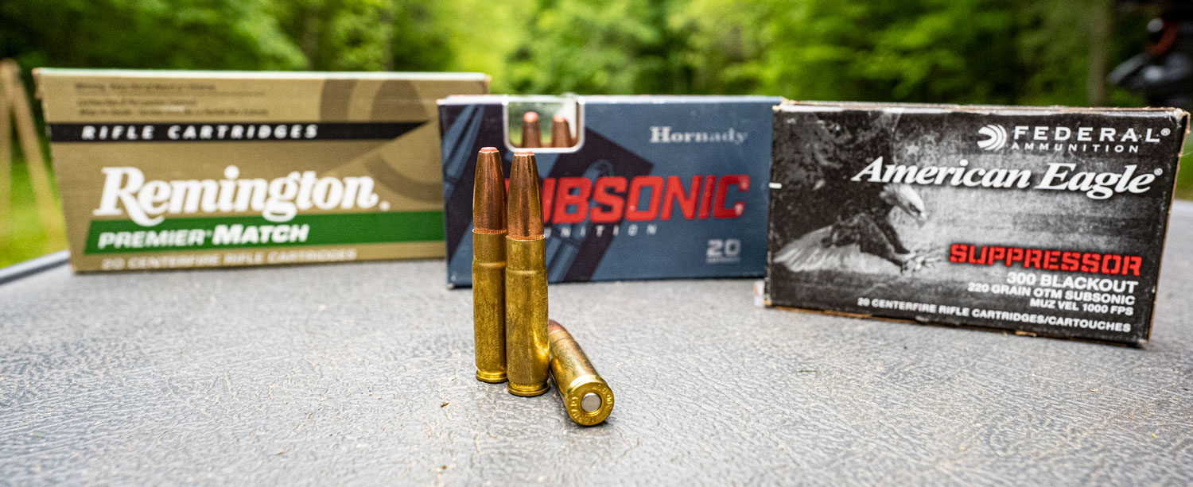
The 300 Blackout is frequently available with 200 and 220 grain bullets. Such large projectiles convey a subsonic muzzle velocity that is accompanied by a quiet report. As such, a subsonic 300 Blackout load makes an ideal accompaniment to a suppressor, suiting it well for (A) tactical situations where ear protection would be impractical, and (B) hunting hogs without scattering the whole pack after the first shot.
The 300 Blackout’s recoil is not significantly different from the 5.56×45, and its price isn’t prohibitively higher. The chief difficulty in accurately firing 300 Blackout comes from learning to accommodate its pronounced bullet drop.
Parent Case | 221 Fireball/223 Rem
Case Type | Rimless, bottleneck
Bullet Diameter | 0.308"
Neck Diameter | 0.334"
Base Diameter | 0.376"
Rim Diameter | 0.378"
Case Length | 1.368"
Overall Length | 2.26"
Maximum Pressure (SAAMI) | 55,000 psi

Other 300 BLK Attributes
- The 300 Blackout’s sleeker bullet has a higher ballistic coefficient than the 5.56×45, but with less speed its trajectory invariably arcs more sharply.
- Although they share .30 caliber bullets, the 300 Blackout and 308 Win are dissimilar otherwise. The latter has nearly twice the propellant, and is therefore better able to fell very distant game.
- A subsonic 300 Blackout round produces comparatively little muzzle flash in addition to a softer report, making it a fine choice for hunting in nighttime and twilight conditions.
- AR-platform rifles optimized to run subsonic 300 Blackout tend to fire supersonic ammo poorly.

